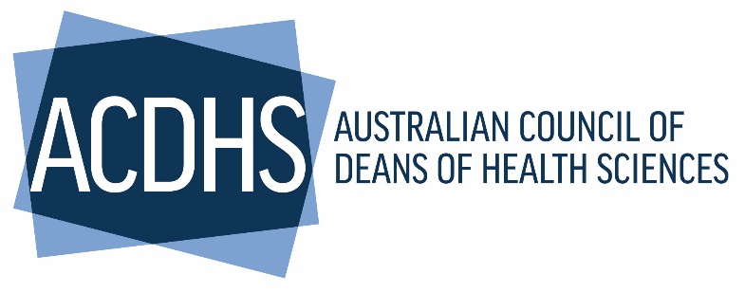
Australian Council of Deans of Health Sciences – Member Workshop
University of Southern Queensland, 293 Queen St, Brisbane 30/4/2024
 | ACDHS Member Workshop | Following AGM
 | Welcome. Acknowledgment of Country.  Member apologies, welcome new members, proxies.  ACDHS Chair Update  - Accord Report Recommendations,  - ACDHS Commissioned Research Project – Placements. Announcement  - National Allied Health Workforce Strategy | 9.30-9.50am  Chair  Prof Michelle Lincoln (ML)
 | GUEST SPEAKER National Allied Health Workforce Strategy.  Insights from state workforce plans.  QLD Chief Allied health Officer, Liza-Jane McBride | 9.50.am- 10.20  L-J McBride
 | MORNING TEA BREAK | 10.20-10.35
 | 2024-2025 Horizon. Symposium topics, Budget and policy submission into 2025 budget and election. | 10.35-10.50am  ML and SM
 | Commissioned Research Project – Placements  Project lead. Methodology and member engagement. | 10.50am-11.45am
 | Scope of Practice Review – Issues paper 2, member input into consultation process and issues for AH position &/or advocacy.  https://www.health.gov.au/sites/default/files/2024-04/unleashing-the-potential-of-our-health-workforce-scope-of-practice-review-issues-paper-2_0.docx | 11.45am-12.15pm Prof Marion Gray
 | LUNCH BREAK | 12.15-1.00pm
 | ACDHS Strategic Plan Objectives and sectoral issues.  Members discussion on identifying the priority areas/issue for ACDHS next commissioned project. Listing and ranking exercise. | 1.00- 1.30pm  Prof Terry Haines  Overview + breakout session
 | GUEST SPEAKER Attracting and retaining students from diverse backgrounds NCSEHE Equity Fellow Dr Andrea Simpson B. Comm. Path., M. Soc. Pol., Ph.D  Researcher in Disability, Health, Access & Inclusion.  Disability Health Research Lead, Monash Health Community  Australian Centre for Student Equity and Access (ACSES) -formerly  The National Centre for Student Equity in Higher Education’s (NCSEHE) | 1.30pm-2.15pm  Presentation and Q&A discussion.  Dr A. Simpson
 | AFTERNOON TEA BREAK | 2.15-2.30
 | Allied Health Academic Workforce – What can ACDHS do to support the AH Academic Workforce?  - ACDHS direct support and development  - Related issues for national advocacy | 2.30pm – 3.00pm  Prof Esther May  Facilitated discussion.
 | Mental Health First Aid – Update Q&A | 3.00pm-3.10pm Leonie Yeomans
 | 2024 Symposium and Awards planning update | 3.10.-3.15pm SM
 | Member feedback – any general business | 3.15.-3.25pm ML & SM
 | Chair to wrap up and close | 3.25pm-3.30pm  ML

